Project publicity
Project title: | Common Education System
Project number: | SP-PDP1-001
Programme name: | Justice
Challange: | .

Programme logos:
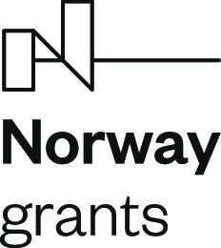
Brief description of the project
This is an educational project that contributes to the innovation and improvement of the professional training and further education of representatives of entities involved in work with persons who are in prison or have recently been released from prison.
Main objectives of the project:
The project’s main objective is to establish a system of common training for staff engaged in penitentiary and post-penitentiary care, involving the development and implementation of individual training modules and component activities that have been identified as pivotal for common training:
1) Innovation of the Basic Training Systems of the Czech Prison Service and the Probation and Mediation Service
2) Manager Training
3) Common Penological Research
4) Mental Health and Burnout Prevention
5) Preparation for Safe Release

Viewed from a society-wide perspective, the project has the tangible potential to improve the quality of care provision and thus help to curb the rate of criminal recidivism. The implementation of this project will also boost bilateral cooperation and relations between the Czech Republic and Norway in correctional services and care for convicted and newly released individuals.
Current project status:
Implementation is now at the halfway point of the period set for the project. Unfortunately, the project has also fallen victim to the COVID-19 pandemic, as agreed training activities had to be cancelled on repeated occasions. This prompted the revision of the educational plan. Where appropriate, training events were organised as distance learning. However, this format proved to be unsuitable for most training courses. Distance learning makes it impossible to carry out the practical exercises that form an important part of the training activities. Interaction between participants was greatly diminished during distance learning. Because of this, mutual contacts and the sharing of good practice were not intensified to the extent envisaged at the beginning of the project.
Since the project started, the following training courses have been delivered:
... as part of the innovation of the training systems of the Czech Prison Service and the Probation and Mediation Service
- Parole for the Probation and Mediation Service
- Probation and Mediation Service Activity, and Alternative Sanctions for the Prison Service
- Probation and Mediation Service, Alternative Sanctions, Parole for the Prison Service
... as part of the Common Penological Research module
- Common Penological Research
... as part of the module on preparations for safe release
- Working with Over-indebted Clients
- Working with Convicted Offenders to Increase their Accountability to the Victim of the Crime and to Address the Consequences of the Crime in a Meaningful Way

Several selected illustrative photographs are attached below...
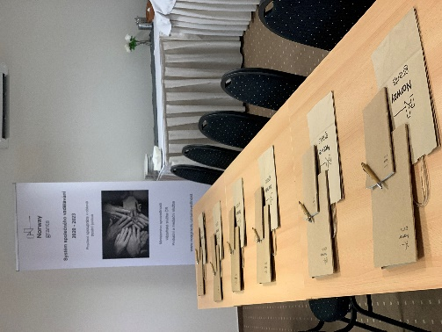 | 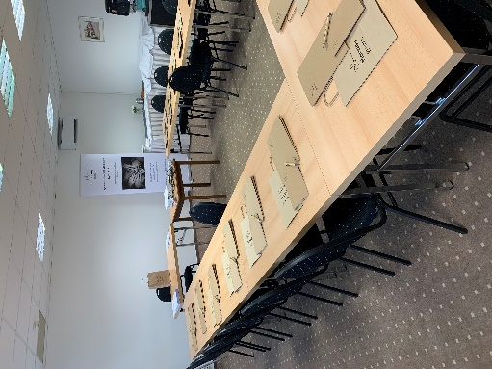
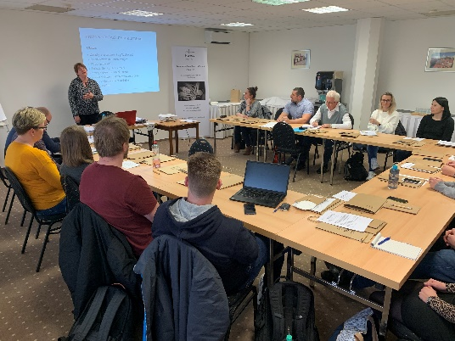 | 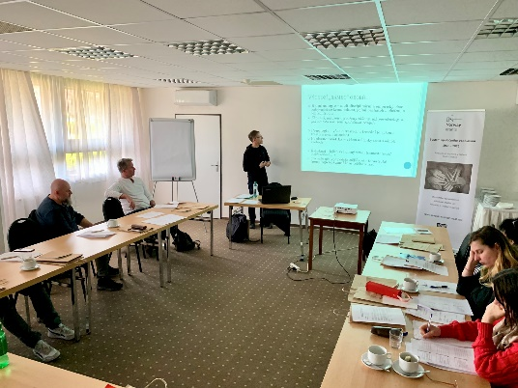
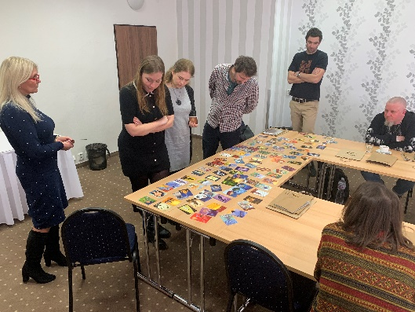 | 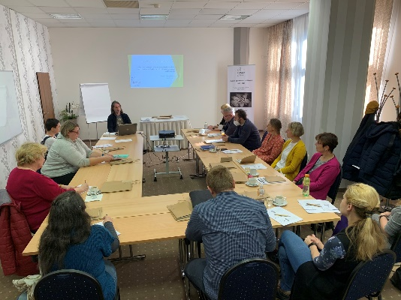
In the second half of the project period, we will continue current training activities while also starting the following training courses:
- Emotional Intelligence Training for Managers
- Mental Health and Burnout Prevention
- Who We Are and the Programmes We Use
- Motivational Interviewing

During the autumn of 2022, the first foreign working trip is planned for Czech experts and representatives of the project’s Norwegian partner, the Norwegian Correctional Services Directorate, whose system has been rated highly and in many ways serves as inspiration for the Czech Republic.
www.eeagrants.org – official websites of the EEA and Norway Funds
www.eeagrants.cz – program provider website
Project budget and funding sources:
The Common Education System project is implemented with the financial support of the Norway Grants 2014-2021
Total amount of support: | 802 000 EUR
EU share: | 681 700 EUR
Czech Republic’s share: | 120 300 EUR
Source of EU support: | Justice Programme under the 2014-2021 Norwegian Financial Mechanism

